24

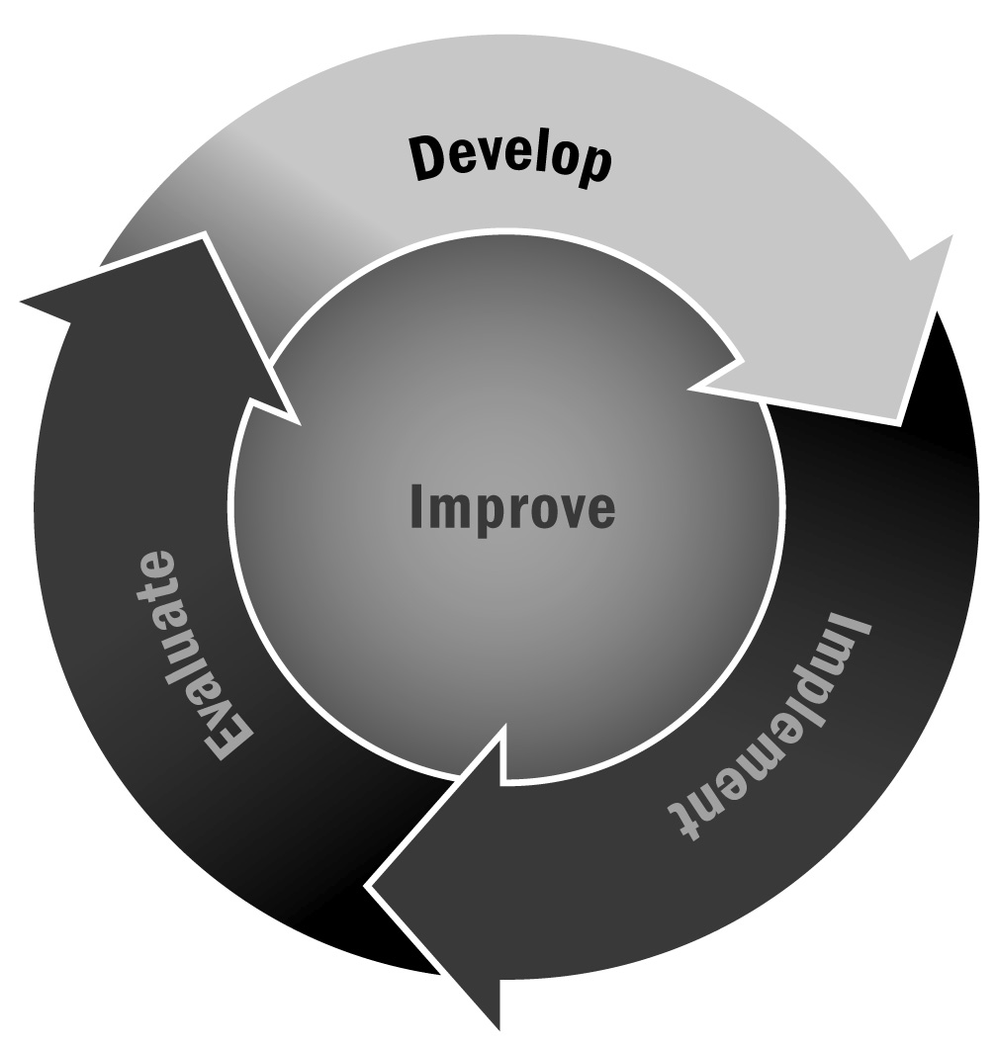
Staff Training Survey
In Chapter 1, you learned that professional development is an important part of supporting staff retention and providing a high-quality program. To that end, it is important to solicit staff member input on professional development topics and to identify what staff members hope to get from the experience.
Directions: Use the survey on the following pages to determine staff training needs and interests for the afterschool and expanded learning program. Distribute the survey to staff members once or twice a year to ensure that everyone feels supported, grows in his or her position, and has an opportunity to give feedback. Program leadership should analyze and distribute staff survey data on a yearly basis.

Tips for Developing and Administering Surveys (For a Full List, See Tool 87)
- Consider your goals and expected outcomes for the survey. What are you trying to learn? Design a survey and develop questions that will help you achieve those goals and answer your ultimate question.
- Make sure you are familiar with the legal and institutional requirements, if any, when surveying families, community members, and especially youth.
- Prioritize your selection of survey questions.
- Consider your audience and make sure your survey will be understood easily.
- Write short questions that respondents can read quickly and easily.
- Make sure that each question has one central idea.
- Focus your questions on suggestions for improvement rather than focusing on negative experiences.
- Avoid leading questions that appear to advocate a particular answer.
- Provide instructions on how to record answers and how many options to select.
- For multiple choice questions, allow respondents to select “Other” so that they can provide another response that wasn’t included in the options.
- Test your survey with a small group before distributing it to all of your intended respondents.
- Think about how you will deliver the survey. Will it be delivered by mail, by telephone, in person, or online? These different methods will affect the survey design. It is likely that a paper survey will be the most convenient method for respondents, but an electronic survey has advantages as well (such as allowing for skip logic and requiring less data entry) if it seems like a viable format for your respondents.
- Provide respondents with a contact person whom they can reach if they have any questions or concerns about the survey.

[Program Name] Staff Training Survey
To All Program Staff:
We need your help! In order to develop a high-quality program, we need to provide all staff members with meaningful learning and skill development opportunities. Please tell us what training activities you would like us to provide. This survey will take only a few minutes to complete.
Please give your completed survey to [name of program director] by [date].
If you have any questions, please call [telephone number] or email [email address].
Thank you for your time.
- What type of training activities do you think we should provide for staff members in the program? (Mark all that apply. Put a * next to the topics that are the highest priority.)
Management
- Fundraising
- Staff development
- Working with an advisory board/board of directors
- Data collection/how to survey youth
- Evaluating your program
Administration/Program Coordination
- Identifying and recruiting participants
- Learning general afterschool and expanded learning program procedures
- Creating a safe program environment
- First aid and CPR
Connecting to the School Day/School Alignment
- Delivering academic content (please specify subject): ________________________________________________
- Linking with the school day
- Successful homework help strategies
- Building relationships with school day teachers and staff
Program Delivery
- Creating a warm and welcoming environment
- Planning hands-on projects
- Creating great lesson plans
- Incorporating reflection into activities
- Providing youth leadership opportunities
- Incorporating the SAFE (sequenced, active, focused, explicit) features into programs
- Promoting positive behavior
- Conflict resolution
- Planning successful field trips
Family and Community Engagement
- Strengthening communication with families
- Involving families in programming
- Community outreach/development
- Creating partnerships for effective programming
- Other: _______________________________________________________________________________________________
- Other: _______________________________________________________________________________________________
- Other: _______________________________________________________________________________________________
- Are you able/willing to provide training to your peers?
- Yes
- No
If yes, on what topics?
- Please suggest any specific trainers or resources you would like us to consider using.

Name (Optional):
Phone (Optional):
Email (Optional):

Thank you.

